W07 Explain Programming with Classes
Author: Thomas Gibb
We have learned about each of four principles of Programming with Classes:
- Abstraction
- Encapsulation
- Inheritance
- Polymorphism
For each of the 4 principles of Programming with Classes, answer the following:
- Briefly define the principle.
- How did you use that principle in one of your programs.
- How did using that principle help that program become more flexible for future changes.
My response must:
- Explain the meaning of each principle.
- Highlight how each principle was used in a program that I wrote.
- Explain how each principle makes that program more flexible for future changes.
- Thoroughly explain these concepts.
Abstraction – my thoughts and ideas:
- Explain the meaning of Abstraction:
  - To me it would provide a method of designing an application and providing a method of giving elements of decision processes and having the functionality coordinated as you give and prove your design decisions.
  - During my working time, I utilized Flow Charts as my design method, and it would allow me to articulate the individual steps that needed to be completed and the decision processes that proved a complete understanding of the design specifications.
  - Abstraction provides this same level of design review and allows you to truly visualize the effect that make it possible to simplify your design.
- Highlight the benefit of Abstraction:
  - It would prove the design specification could be met and have all the elements completely satisfied.
  - After a thorough review, you could implement changes to methods and processes that would make your project easier to complete.
- Provide an application for Abstraction:
  - When you have multiple layers of a project, having a thoroughly reviewed Flow Chart of the project would allow you to see possible reusable elements that could be utilized across the project and simplify or reduce complexity of the project.
Encapsulation – my thoughts and ideas:
- Explain the meaning of Encapsulation:
  - This is a functionality that provides a method to make your application more secure and reduce the possibility of having someone hack your code and change the meaning and functionality of your processes.
  - This provides a minimum of security and can help you to validate the information that you enter or that a client will enter as you strive to input parameter checks
- Highlight the benefit of Encapsulation:
  - It helps to ensure that the console entries are correct and will not cause a malfunction in your code.
  - Also helps to validate your processes and helps to keep some of your thought process organized as you design and facilitate your working environment.
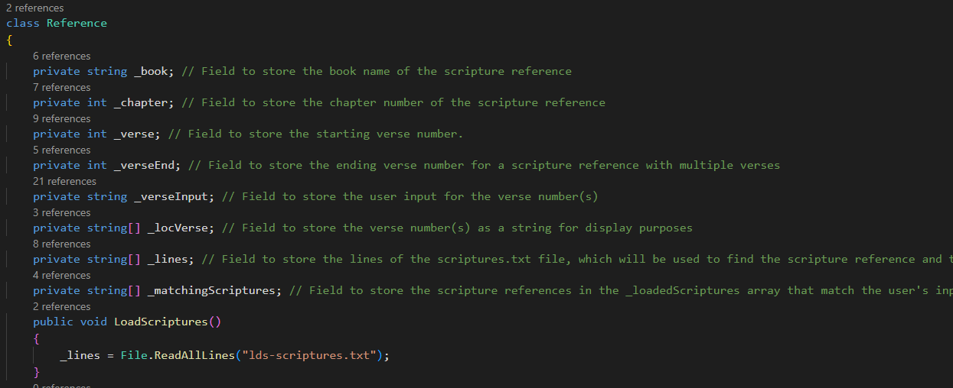
- The ‘private’ functions of my code as well as the “public void LoadScriptures()” function that simplifies the process of loading the scripture source that I have chosen to load into the private variable “_lines”.
- This makes it easy to validate that the chosen scriptures are already loaded and that I do not have to reload them during their usage in various processes in the code.
- The above example also shows how many times each element is used in the various C# processes and will allow me to easily locate them and validate their correct usage.
Inheritance – my thoughts and ideas:
- Explain the meaning of Inheritance.
  - Provides a method of defining common functions at the base level that can be re-utilized in sub-functions.
  - By using these common functions, it simplifies the ability to maintain and improve the operation of sub-functions without having to do any code re-design within them.
- Highlight the benefit of Inheritance.
  - Provides a common point to accomplish the update to functions that are utilized across the sub-functions.
- Provide an application for Inheritance.
  - When a timer is designed that can be utilized across sub functions, it simplifies the extent of the design and reduces waste and eliminates complexity.
- Use a code example of Inheritance from the program you wrote.
- 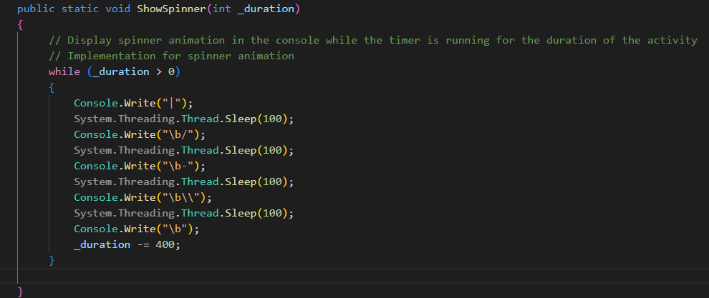

- Thoroughly explain these concepts.
  - It was an interesting concept to build and made for some awesome code that I’m able to re-utilize across several functions to allow me to display a timer that will decrement from a predesignated time frame. I do not need to re-build this spinner function in any of the sub functions because I can call it from the base activity and make it a useful concept.
  - I’ve been looking at this and going, wow, this would and will be very useful as it allows us to build programs that are easier to debug, make modifications to and allows me to see and optimize my complexity and functional durability as well as limit my exposure to possible compromise.
Polymorphism – my thoughts and ideas:
- Explain the meaning of Polymorphism:
  - Polymorphism is the ability to re-utilize the same functional call in a base class to complete a different function. Each individual linked call will be able to adapt and utilize the top-level function and complete an alternative goal
- Highlight a benefit of Polymorphism:
  - This makes it possible for the application designer to apply different rules to a sub function and thereby cause an improved execution matrix to be completed.
  - This can simplify the overall functionality of your application.
- Provide an application of Polymorphism:
  - An example would be to have a functional call perform an update and return a different result depending on how the data was defined.
  - This would allow you to store different types of information in a list and then provide a method of using the same function to do different actions depending on what the contents of the stored information were set to explore.
- Show a coding example of Polymorphism from the program you wrote.
- 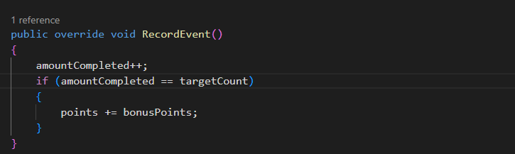
- To me, the ability to re-utilize the ‘RecordEvent()’ as shown above in multiple elements of your application provides a strong example of being able to overcome similar functions without having to re-design and re-build the common code base. When this happens, it simplifies the ability of maintaining your code and allows you to use it and keep your code smaller in overall scope.
  - When I was working at Martin Marietta, I had to re-use a lot of code in my ‘Comet’ application which grew to over 200,00 lines of code. Lots of re-entrant code examples, but since it was a script-based application, it became very un-friendly for maintenance. I had done a thorough implementation of commenting the applications so that it was not difficult to follow the overall scope, but if I had not done the commenting, it would have been a real nightmare.

